**Walmart Business Problems**

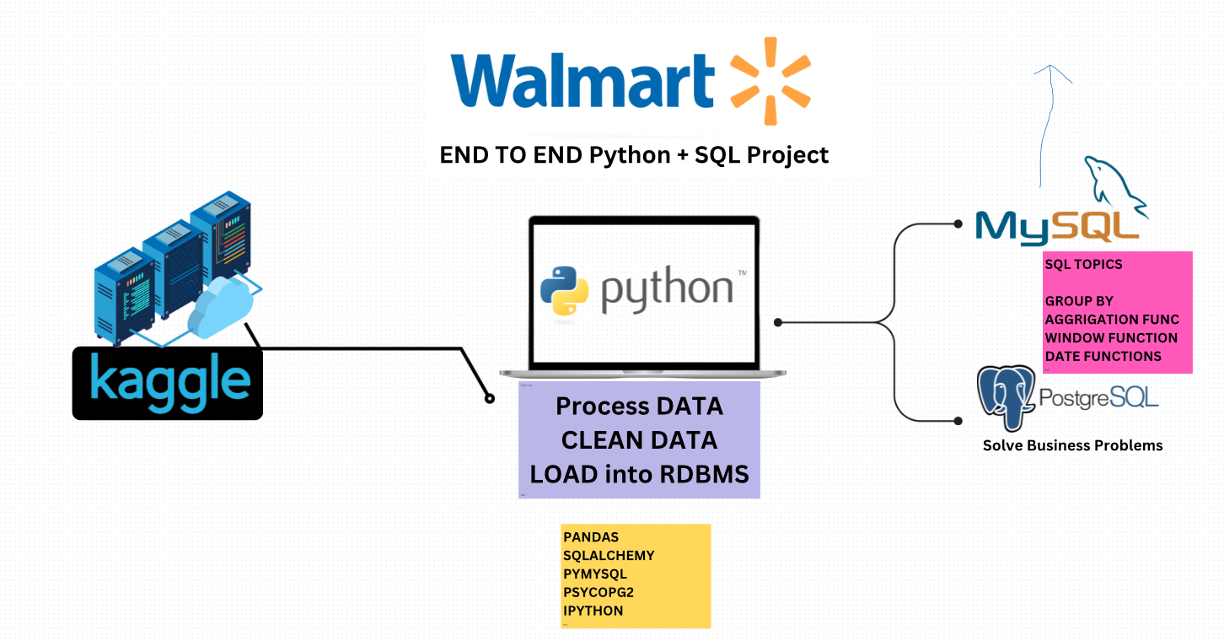

**SQL Part**

1. Analyze Payment Methods and Sales ● Question: What are the different payment methods, and how many transactions and items were sold with each method? ● Purpose: This helps understand customer preferences for payment methods, aiding in payment optimization strategies.

2. Identify the Highest-Rated Category in Each Branch ● Question: Which category received the highest average rating in each branch? ● Purpose: This allows Walmart to recognize and promote popular categories in specific branches, enhancing customer satisfaction and branch-specific marketing.

3. Determine the Busiest Day for Each Branch ● Question: What is the busiest day of the week for each branch based on transaction volume? ● Purpose: This insight helps in optimizing staffing and inventory management to accommodate peak days.

4. Calculate Total Quantity Sold by Payment Method ● Question: How many items were sold through each payment method? ● Purpose: This helps Walmart track sales volume by payment type, providing insights into customer purchasing habits.

5. Analyze Category Ratings by City ● Question: What are the average, minimum, and maximum ratings for each category in each city? ● Purpose: This data can guide city-level promotions, allowing Walmart to address regional preferences and improve customer experiences.

6. Calculate Total Profit by Category ● Question: What is the total profit for each category, ranked from highest to lowest? ● Purpose: Identifying high-profit categories helps focus efforts on expanding these products or managing pricing strategies effectively.

7. Determine the Most Common Payment Method per Branch ● Question: What is the most frequently used payment method in each branch? ● Purpose: This information aids in understanding branch-specific payment preferences, potentially allowing branches to streamline their payment processing systems.

8. Analyze Sales Shifts Throughout the Day ● Question: How many transactions occur in each shift (Morning, Afternoon, Evening) across branches? ● Purpose: This insight helps in managing staff shifts and stock replenishment schedules, especially during high-sales periods.

9. Identify Branches with Highest Revenue Decline Year-Over-Year ● Question: Which branches experienced the largest decrease in revenue compared to the previous year? ● Purpose: Detecting branches with declining revenue is crucial for understanding possible local issues and creating strategies to boost sales or mitigate losses

**PowerBI Part**

**Business Problems to Solve:**

**🔹 1. Which branch generates the highest revenue and profit?**

* Compare **sales and profit** across branches and cities.
* Identify **top-performing** and **low-performing** locations.

**🔹 2. Which product categories are most profitable?**

* Break down sales by category
* Compare total profit vs unit price to find high-margin categories

**🔹 3. What is the sales and profit trend over time?**

* Analyze daily, weekly, or monthly trends using the date column.
* Highlight peak seasons or low-performance periods.

**🔹 4. Which payment method is most used by customers?**

* Understand customer preferences for cash, credit, e-wallet, etc.
* Correlate payment method with average purchase value.

**🔹 5. What is the customer satisfaction level across branches?**

* Use rating to measure average satisfaction per branch/category.
* Link poor ratings to specific payment methods or low-profit items.

**📈 Key KPIs to Show on Top:**

| **KPI Title** | **Formula / Column Used** |
| --- | --- |
| 🧾 Total Revenue | SUM(unit_price * quantity) |
| 💰 Total Profit | SUM(total profit) |
| 🛍️ Total Quantity Sold | SUM(quantity) |
| 🏢 Best Performing Branch | Branch with MAX(total profit) |
| 📊 Avg Rating | AVERAGE(rating) |
| 💳 Most Used Payment Method | MODE(payment_method) |